Pronouncing Dictionary

What is Pronouncing Dictionary
# Source: AI Source: Provided by: [Data Path: Persons Table -> ID Column: 1, Name_En Column: Motasem Essam] -> From: [Chatgpt (GPT-4-turbo)] on [7/29/2025]
A Pronouncing Dictionary is a specialized reference that provides the correct pronunciation of words, often using phonetic transcriptions such as the International Phonetic Alphabet (IPA). These dictionaries are especially useful for language learners, actors, linguists, and speech professionals.

🔹 Key Features of a Pronouncing Dictionary
# Source: AI Source: Provided by: [Data Path: Persons Table -> ID Column: 1, Name_En Column: Motasem Essam] -> From: [Chatgpt (GPT-4-turbo)] on [7/29/2025]
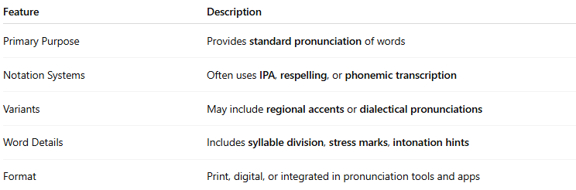
Feature | Description
Primary Purpose | Provides standard pronunciation of words
Notation Systems | Often uses IPA, respelling, or phonemic transcription
Variants | May include regional accents or dialectical pronunciations
Word Details | Includes syllable division, stress marks, intonation hints
Format | Print, digital, or integrated in pronunciation tools and apps

🔹 Examples of Pronouncing Dictionaries
# Source: AI Source: Provided by: [Data Path: Persons Table -> ID Column: 1, Name_En Column: Motasem Essam] -> From: [Chatgpt (GPT-4-turbo)] on [7/29/2025]
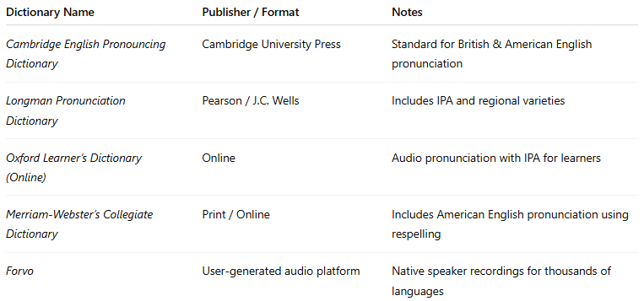
Dictionary Name | Publisher / Format | Notes
Cambridge English Pronouncing Dictionary | Cambridge University Press | Standard for British & American English pronunciation
Longman Pronunciation Dictionary | Pearson / J.C. Wells | Includes IPA and regional varieties
Oxford Learner’s Dictionary (Online) | Online | Audio pronunciation with IPA for learners
Merriam-Webster’s Collegiate Dictionary | Print / Online | Includes American English pronunciation using respelling
Forvo | User-generated audio platform | Native speaker recordings for thousands of languages

🔹 Advantages
# Source: AI Source: Provided by: [Data Path: Persons Table -> ID Column: 1, Name_En Column: Motasem Essam] -> From: [Chatgpt (GPT-4-turbo)] on [7/29/2025]
- Helps learners develop accurate pronunciation
- Supports phonetics and phonology research
- Useful for acting, speech therapy, and broadcasting
- Clarifies differences in regional pronunciation

🔹 Use Cases
# Source: AI Source: Provided by: [Data Path: Persons Table -> ID Column: 1, Name_En Column: Motasem Essam] -> From: [Chatgpt (GPT-4-turbo)] on [7/29/2025]
- Language learning (especially ESL/EFL)
- Voice training, acting, and broadcasting
- Linguistic and phonetic studies
- Speech therapy and accent correction

